Schema dimr-1.2.xsd

schema location: | D:\temp\dimr-1.2.xsd
attributeFormDefault:
elementFormDefault: | qualified
targetNamespace: | http://schemas.deltares.nl/dimr

Elements | Complex types
dimrConfig | dimrComponentOrCouplerRefXML
 | dimrComponentXML
 | dimrControlXML
 | dimrCoupledItemXML
 | dimrCouplerXML
 | dimrDocumentationXML
 | dimrKeyValuePairXML
 | DimrLoggerXML
 | dimrParallelXML
 | dimrSequentialXML
 | dimrStartGroupXML
 | dimrXML

element dimrConfig
diagram | 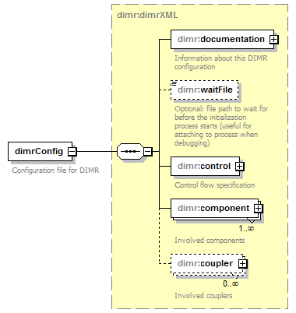
namespace | http://schemas.deltares.nl/dimr
type | dimr:dimrXML
properties
  content | complex
children | dimr:documentation dimr:waitFile dimr:control dimr:component dimr:coupler
annotation
  documentation
  Configuration file for DIMR
source | <xs:element name="dimrConfig" type="dimr:dimrXML">  <xs:annotation>  <xs:documentation>Configuration file for DIMR</xs:documentation>  </xs:annotation>  </xs:element>

complexType dimrComponentOrCouplerRefXML
diagram | 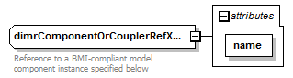
namespace | http://schemas.deltares.nl/dimr
used by
  elements | dimrStartGroupXML/coupler dimrControlXML/start dimrParallelXML/start dimrParallelXML/start dimrStartGroupXML/start dimrSequentialXML/start
attributes
  Name | Type | Use | Default | Fixed | Annotation
  name | xs:string | required
annotation
  documentation
  Reference to a BMI-compliant model component instance specified below
source | <xs:complexType name="dimrComponentOrCouplerRefXML">  <xs:annotation>  <xs:documentation>Reference to a BMI-compliant model component instance specified below</xs:documentation>  </xs:annotation>  <xs:attribute name="name" type="xs:string" use="required"/>  </xs:complexType>

attribute dimrComponentOrCouplerRefXML/@name
type | xs:string
properties
  use | required
source | <xs:attribute name="name" type="xs:string" use="required"/>

complexType dimrComponentXML
diagram | 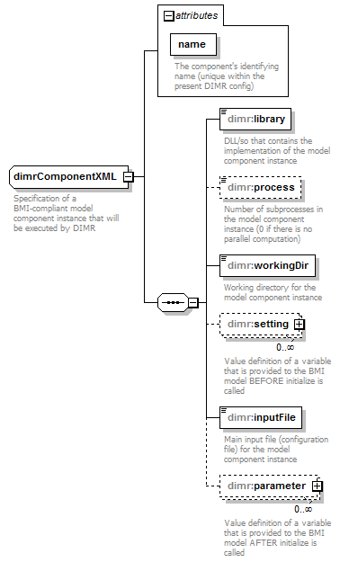
namespace | http://schemas.deltares.nl/dimr
children | dimr:library dimr:process dimr:workingDir dimr:setting dimr:inputFile dimr:parameter
used by
  element | dimrXML/component
attributes
  Name | Type | Use | Default | Fixed | Annotation
  name | xs:string | required
    documentation
    The component's identifying name (unique within the present DIMR config)
annotation
  documentation
  Specification of a BMI-compliant model component instance that will be executed by DIMR
source | <xs:complexType name="dimrComponentXML">  <xs:annotation>  <xs:documentation>Specification of a BMI-compliant model component instance that will be executed by DIMR</xs:documentation>  </xs:annotation>  <xs:sequence>  <xs:element name="library" type="xs:string">  <xs:annotation>  <xs:documentation>DLL/so that contains the implementation of the model component instance</xs:documentation>  </xs:annotation>  </xs:element>  <xs:element name="process" type="xs:integer" default="0" minOccurs="0">  <xs:annotation>  <xs:documentation>Number of subprocesses in the model component instance (0 if there is no parallel computation)</xs:documentation>  </xs:annotation>  </xs:element>  <xs:element name="workingDir" type="xs:string">  <xs:annotation>  <xs:documentation>Working directory for the model component instance</xs:documentation>  </xs:annotation>  </xs:element>  <xs:element name="setting" type="dimr:dimrKeyValuePairXML" minOccurs="0" maxOccurs="unbounded">  <xs:annotation>  <xs:documentation>Value definition of a variable that is provided to the BMI model BEFORE initialize is called</xs:documentation>  </xs:annotation>  </xs:element>  <xs:element name="inputFile" type="xs:string">  <xs:annotation>  <xs:documentation>Main input file (configuration file) for the model component instance</xs:documentation>  </xs:annotation>  </xs:element>  <xs:element name="parameter" type="dimr:dimrKeyValuePairXML" minOccurs="0" maxOccurs="unbounded">  <xs:annotation>  <xs:documentation>Value definition of a variable that is provided to the BMI model AFTER initialize is called</xs:documentation>  </xs:annotation>  </xs:element>  </xs:sequence>  <xs:attribute name="name" type="xs:string" use="required">  <xs:annotation>  <xs:documentation>The component's identifying name (unique within the present DIMR config)</xs:documentation>  </xs:annotation>  </xs:attribute>  </xs:complexType>

attribute dimrComponentXML/@name
type | xs:string
properties
  use | required
annotation
  documentation
  The component's identifying name (unique within the present DIMR config)
source | <xs:attribute name="name" type="xs:string" use="required">  <xs:annotation>  <xs:documentation>The component's identifying name (unique within the present DIMR config)</xs:documentation>  </xs:annotation>  </xs:attribute>

element dimrComponentXML/library
diagram | 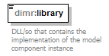
namespace | http://schemas.deltares.nl/dimr
type | xs:string
properties
  content | simple
annotation
  documentation
  DLL/so that contains the implementation of the model component instance
source | <xs:element name="library" type="xs:string">  <xs:annotation>  <xs:documentation>DLL/so that contains the implementation of the model component instance</xs:documentation>  </xs:annotation>  </xs:element>

element dimrComponentXML/process
diagram | 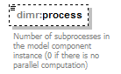
namespace | http://schemas.deltares.nl/dimr
type | xs:integer
properties
  minOcc | 0
  maxOcc | 1
  content | simple
  default | 0
annotation
  documentation
  Number of subprocesses in the model component instance (0 if there is no parallel computation)
source | <xs:element name="process" type="xs:integer" default="0" minOccurs="0">  <xs:annotation>  <xs:documentation>Number of subprocesses in the model component instance (0 if there is no parallel computation)</xs:documentation>  </xs:annotation>  </xs:element>

element dimrComponentXML/workingDir
diagram | 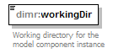
namespace | http://schemas.deltares.nl/dimr
type | xs:string
properties
  content | simple
annotation
  documentation
  Working directory for the model component instance
source | <xs:element name="workingDir" type="xs:string">  <xs:annotation>  <xs:documentation>Working directory for the model component instance</xs:documentation>  </xs:annotation>  </xs:element>

element dimrComponentXML/setting
diagram | 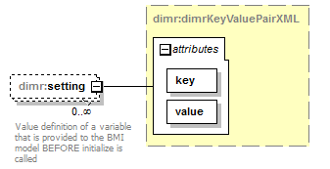
namespace | http://schemas.deltares.nl/dimr
type | dimr:dimrKeyValuePairXML
properties
  minOcc | 0
  maxOcc | unbounded
  content | complex
attributes
  Name | Type | Use | Default | Fixed | Annotation
  key | xs:string | required
  value | xs:string | required
annotation
  documentation
  Value definition of a variable that is provided to the BMI model BEFORE initialize is called
source | <xs:element name="setting" type="dimr:dimrKeyValuePairXML" minOccurs="0" maxOccurs="unbounded">  <xs:annotation>  <xs:documentation>Value definition of a variable that is provided to the BMI model BEFORE initialize is called</xs:documentation>  </xs:annotation>  </xs:element>

element dimrComponentXML/inputFile
diagram | 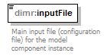
namespace | http://schemas.deltares.nl/dimr
type | xs:string
properties
  content | simple
annotation
  documentation
  Main input file (configuration file) for the model component instance
source | <xs:element name="inputFile" type="xs:string">  <xs:annotation>  <xs:documentation>Main input file (configuration file) for the model component instance</xs:documentation>  </xs:annotation>  </xs:element>

element dimrComponentXML/parameter
diagram | 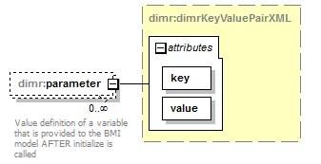
namespace | http://schemas.deltares.nl/dimr
type | dimr:dimrKeyValuePairXML
properties
  minOcc | 0
  maxOcc | unbounded
  content | complex
attributes
  Name | Type | Use | Default | Fixed | Annotation
  key | xs:string | required
  value | xs:string | required
annotation
  documentation
  Value definition of a variable that is provided to the BMI model AFTER initialize is called
source | <xs:element name="parameter" type="dimr:dimrKeyValuePairXML" minOccurs="0" maxOccurs="unbounded">  <xs:annotation>  <xs:documentation>Value definition of a variable that is provided to the BMI model AFTER initialize is called</xs:documentation>  </xs:annotation>  </xs:element>

complexType dimrControlXML
diagram | 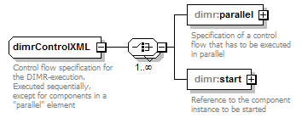
namespace | http://schemas.deltares.nl/dimr
children | dimr:parallel dimr:start
used by
  element | dimrXML/control
annotation
  documentation
  Control flow specification for the DIMR-execution. Executed sequentially, except for components in a "parallel" element
source | <xs:complexType name="dimrControlXML">  <xs:annotation>  <xs:documentation>Control flow specification for the DIMR-execution. Executed sequentially, except for components in a "parallel" element</xs:documentation>  </xs:annotation>  <xs:choice maxOccurs="unbounded">  <xs:element name="parallel" type="dimr:dimrParallelXML">  <xs:annotation>  <xs:documentation>Specification of a control flow that has to be executed in parallel</xs:documentation>  </xs:annotation>  </xs:element>  <xs:element name="start" type="dimr:dimrComponentOrCouplerRefXML">  <xs:annotation>  <xs:documentation>Reference to the component instance to be started</xs:documentation>  </xs:annotation>  </xs:element>  </xs:choice>  </xs:complexType>

element dimrControlXML/parallel
diagram | 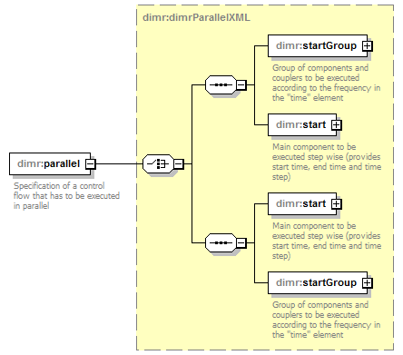
namespace | http://schemas.deltares.nl/dimr
type | dimr:dimrParallelXML
properties
  content | complex
children | dimr:startGroup dimr:start dimr:start dimr:startGroup
annotation
  documentation
  Specification of a control flow that has to be executed in parallel
source | <xs:element name="parallel" type="dimr:dimrParallelXML">  <xs:annotation>  <xs:documentation>Specification of a control flow that has to be executed in parallel</xs:documentation>  </xs:annotation>  </xs:element>

element dimrControlXML/start
diagram | 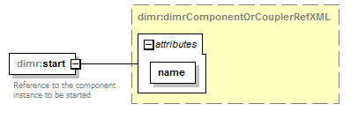
namespace | http://schemas.deltares.nl/dimr
type | dimr:dimrComponentOrCouplerRefXML
properties
  content | complex
attributes
  Name | Type | Use | Default | Fixed | Annotation
  name | xs:string | required
annotation
  documentation
  Reference to the component instance to be started
source | <xs:element name="start" type="dimr:dimrComponentOrCouplerRefXML">  <xs:annotation>  <xs:documentation>Reference to the component instance to be started</xs:documentation>  </xs:annotation>  </xs:element>

complexType dimrCoupledItemXML
diagram | 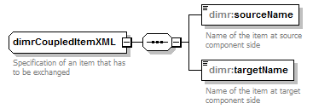
namespace | http://schemas.deltares.nl/dimr
children | dimr:sourceName dimr:targetName
used by
  element | dimrCouplerXML/item
annotation
  documentation
  Specification of an item that has to be exchanged
source | <xs:complexType name="dimrCoupledItemXML">  <xs:annotation>  <xs:documentation>Specification of an item that has to be exchanged</xs:documentation>  </xs:annotation>  <xs:sequence>  <xs:element name="sourceName" type="xs:string">  <xs:annotation>  <xs:documentation>Name of the item at source component side</xs:documentation>  </xs:annotation>  </xs:element>  <xs:element name="targetName" type="xs:string">  <xs:annotation>  <xs:documentation>Name of the item at target component side</xs:documentation>  </xs:annotation>  </xs:element>  </xs:sequence>  </xs:complexType>

element dimrCoupledItemXML/sourceName
diagram | 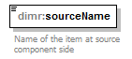
namespace | http://schemas.deltares.nl/dimr
type | xs:string
properties
  content | simple
annotation
  documentation
  Name of the item at source component side
source | <xs:element name="sourceName" type="xs:string">  <xs:annotation>  <xs:documentation>Name of the item at source component side</xs:documentation>  </xs:annotation>  </xs:element>

element dimrCoupledItemXML/targetName
diagram | 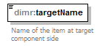
namespace | http://schemas.deltares.nl/dimr
type | xs:string
properties
  content | simple
annotation
  documentation
  Name of the item at target component side
source | <xs:element name="targetName" type="xs:string">  <xs:annotation>  <xs:documentation>Name of the item at target component side</xs:documentation>  </xs:annotation>  </xs:element>

complexType dimrCouplerXML
diagram | 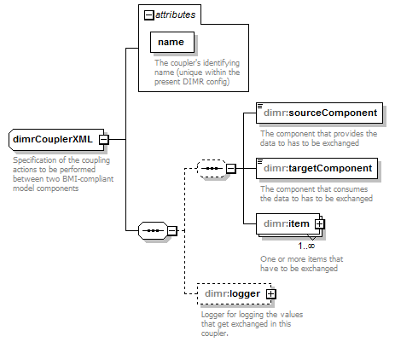
namespace | http://schemas.deltares.nl/dimr
children | dimr:sourceComponent dimr:targetComponent dimr:item dimr:logger
used by
  element | dimrXML/coupler
attributes
  Name | Type | Use | Default | Fixed | Annotation
  name | xs:string | required
    documentation
    The coupler's identifying name (unique within the present DIMR config)
annotation
  documentation
  Specification of the coupling actions to be performed between two BMI-compliant model components
source | <xs:complexType name="dimrCouplerXML">  <xs:annotation>  <xs:documentation>Specification of the coupling actions to be performed between two BMI-compliant model components</xs:documentation>  </xs:annotation>  <xs:sequence>  <xs:sequence minOccurs="0">  <xs:element name="sourceComponent" type="xs:string">  <xs:annotation>  <xs:documentation>The component that provides the data to has to be exchanged</xs:documentation>  </xs:annotation>  </xs:element>  <xs:element name="targetComponent" type="xs:string">  <xs:annotation>  <xs:documentation>The component that consumes the data to has to be exchanged</xs:documentation>  </xs:annotation>  </xs:element>  <xs:element name="item" type="dimr:dimrCoupledItemXML" maxOccurs="unbounded">  <xs:annotation>  <xs:documentation>One or more items that have to be exchanged</xs:documentation>  </xs:annotation>  </xs:element>  </xs:sequence>  <xs:element name="logger" type="dimr:DimrLoggerXML" minOccurs="0" maxOccurs="1">  <xs:annotation>  <xs:documentation>Logger for logging the values that get exchanged in this coupler.</xs:documentation>  </xs:annotation>  </xs:element>  </xs:sequence>  <xs:attribute name="name" type="xs:string" use="required">  <xs:annotation>  <xs:documentation>The coupler's identifying name (unique within the present DIMR config)</xs:documentation>  </xs:annotation>  </xs:attribute>  </xs:complexType>

attribute dimrCouplerXML/@name
type | xs:string
properties
  use | required
annotation
  documentation
  The coupler's identifying name (unique within the present DIMR config)
source | <xs:attribute name="name" type="xs:string" use="required">  <xs:annotation>  <xs:documentation>The coupler's identifying name (unique within the present DIMR config)</xs:documentation>  </xs:annotation>  </xs:attribute>

element dimrCouplerXML/sourceComponent
diagram | 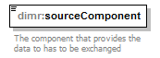
namespace | http://schemas.deltares.nl/dimr
type | xs:string
properties
  content | simple
annotation
  documentation
  The component that provides the data to has to be exchanged
source | <xs:element name="sourceComponent" type="xs:string">  <xs:annotation>  <xs:documentation>The component that provides the data to has to be exchanged</xs:documentation>  </xs:annotation>  </xs:element>

element dimrCouplerXML/targetComponent
diagram | 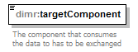
namespace | http://schemas.deltares.nl/dimr
type | xs:string
properties
  content | simple
annotation
  documentation
  The component that consumes the data to has to be exchanged
source | <xs:element name="targetComponent" type="xs:string">  <xs:annotation>  <xs:documentation>The component that consumes the data to has to be exchanged</xs:documentation>  </xs:annotation>  </xs:element>

element dimrCouplerXML/item
diagram | 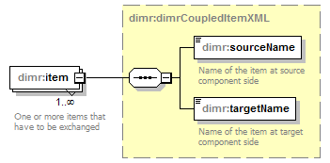
namespace | http://schemas.deltares.nl/dimr
type | dimr:dimrCoupledItemXML
properties
  minOcc | 1
  maxOcc | unbounded
  content | complex
children | dimr:sourceName dimr:targetName
annotation
  documentation
  One or more items that have to be exchanged
source | <xs:element name="item" type="dimr:dimrCoupledItemXML" maxOccurs="unbounded">  <xs:annotation>  <xs:documentation>One or more items that have to be exchanged</xs:documentation>  </xs:annotation>  </xs:element>

element dimrCouplerXML/logger
diagram | 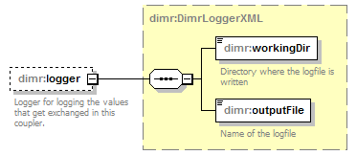
namespace | http://schemas.deltares.nl/dimr
type | dimr:DimrLoggerXML
properties
  minOcc | 0
  maxOcc | 1
  content | complex
children | dimr:workingDir dimr:outputFile
annotation
  documentation
  Logger for logging the values that get exchanged in this coupler.
source | <xs:element name="logger" type="dimr:DimrLoggerXML" minOccurs="0" maxOccurs="1">  <xs:annotation>  <xs:documentation>Logger for logging the values that get exchanged in this coupler.</xs:documentation>  </xs:annotation>  </xs:element>

complexType dimrDocumentationXML
diagram | 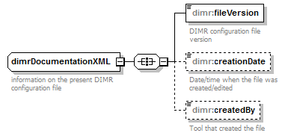
namespace | http://schemas.deltares.nl/dimr
children | dimr:fileVersion dimr:creationDate dimr:createdBy
used by
  element | dimrXML/documentation
annotation
  documentation
  information on the present DIMR configuration file
source | <xs:complexType name="dimrDocumentationXML">  <xs:annotation>  <xs:documentation>information on the present DIMR configuration file</xs:documentation>  </xs:annotation>  <xs:all>  <xs:element name="fileVersion">  <xs:annotation>  <xs:documentation>DIMR configuration file version</xs:documentation>  </xs:annotation>  <xs:simpleType>  <xs:restriction base="xs:decimal">  <xs:enumeration value="1.0">  <xs:annotation>  <xs:documentation>First version</xs:documentation>  </xs:annotation>  </xs:enumeration>  <xs:enumeration value="1.1">  <xs:annotation>  <xs:documentation>Added settings/parameters. Fully backwards compatible with previous versions</xs:documentation>  </xs:annotation>  </xs:enumeration>  <xs:enumeration value="1.2">  <xs:annotation>  <xs:documentation>Added more settings/parameters. Fully backwards compatible with previous versions</xs:documentation>  </xs:annotation>  </xs:enumeration>  </xs:restriction>  </xs:simpleType>  </xs:element>  <xs:element name="creationDate" type="xs:dateTime" minOccurs="0">  <xs:annotation>  <xs:documentation>Date/time when the file was created/edited</xs:documentation>  </xs:annotation>  </xs:element>  <xs:element name="createdBy" type="xs:string" minOccurs="0">  <xs:annotation>  <xs:documentation>Tool that created the file</xs:documentation>  </xs:annotation>  </xs:element>  </xs:all>  </xs:complexType>

element dimrDocumentationXML/fileVersion
diagram | 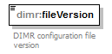
namespace | http://schemas.deltares.nl/dimr
type | restriction of xs:decimal
properties
  content | simple
facets
  Kind | Value | Annotation
  enumeration | 1.0
    documentation
    First version
  enumeration | 1.1
    documentation
    Added settings/parameters. Fully backwards compatible with previous versions
  enumeration | 1.2
    documentation
    Added more settings/parameters. Fully backwards compatible with previous versions
annotation
  documentation
  DIMR configuration file version
source | <xs:element name="fileVersion">  <xs:annotation>  <xs:documentation>DIMR configuration file version</xs:documentation>  </xs:annotation>  <xs:simpleType>  <xs:restriction base="xs:decimal">  <xs:enumeration value="1.0">  <xs:annotation>  <xs:documentation>First version</xs:documentation>  </xs:annotation>  </xs:enumeration>  <xs:enumeration value="1.1">  <xs:annotation>  <xs:documentation>Added settings/parameters. Fully backwards compatible with previous versions</xs:documentation>  </xs:annotation>  </xs:enumeration>  <xs:enumeration value="1.2">  <xs:annotation>  <xs:documentation>Added more settings/parameters. Fully backwards compatible with previous versions</xs:documentation>  </xs:annotation>  </xs:enumeration>  </xs:restriction>  </xs:simpleType>  </xs:element>

element dimrDocumentationXML/creationDate
diagram | 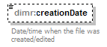
namespace | http://schemas.deltares.nl/dimr
type | xs:dateTime
properties
  minOcc | 0
  maxOcc | 1
  content | simple
annotation
  documentation
  Date/time when the file was created/edited
source | <xs:element name="creationDate" type="xs:dateTime" minOccurs="0">  <xs:annotation>  <xs:documentation>Date/time when the file was created/edited</xs:documentation>  </xs:annotation>  </xs:element>

element dimrDocumentationXML/createdBy
diagram | 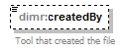
namespace | http://schemas.deltares.nl/dimr
type | xs:string
properties
  minOcc | 0
  maxOcc | 1
  content | simple
annotation
  documentation
  Tool that created the file
source | <xs:element name="createdBy" type="xs:string" minOccurs="0">  <xs:annotation>  <xs:documentation>Tool that created the file</xs:documentation>  </xs:annotation>  </xs:element>

complexType dimrKeyValuePairXML
diagram | 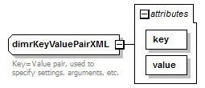
namespace | http://schemas.deltares.nl/dimr
used by
  elements | dimrComponentXML/parameter dimrComponentXML/setting
attributes
  Name | Type | Use | Default | Fixed | Annotation
  key | xs:string | required
  value | xs:string | required
annotation
  documentation
  Key=Value pair, used to specify settings, arguments, etc.
source | <xs:complexType name="dimrKeyValuePairXML">  <xs:annotation>  <xs:documentation>Key=Value pair, used to specify settings, arguments, etc.</xs:documentation>  </xs:annotation>  <xs:attribute name="key" type="xs:string" use="required"/>  <xs:attribute name="value" type="xs:string" use="required"/>  </xs:complexType>

attribute dimrKeyValuePairXML/@key
type | xs:string
properties
  use | required
source | <xs:attribute name="key" type="xs:string" use="required"/>

attribute dimrKeyValuePairXML/@value
type | xs:string
properties
  use | required
source | <xs:attribute name="value" type="xs:string" use="required"/>

complexType DimrLoggerXML
diagram | 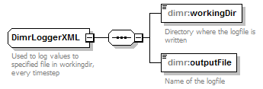
namespace | http://schemas.deltares.nl/dimr
children | dimr:workingDir dimr:outputFile
used by
  element | dimrCouplerXML/logger
annotation
  documentation
  Used to log values to specified file in workingdir, every timestep
source | <xs:complexType name="DimrLoggerXML">  <xs:annotation>  <xs:documentation>Used to log values to specified file in workingdir, every timestep</xs:documentation>  </xs:annotation>  <xs:sequence>  <xs:element name="workingDir" minOccurs="1" maxOccurs="1">  <xs:annotation>  <xs:documentation>Directory where the logfile is written</xs:documentation>  </xs:annotation>  <xs:simpleType>  <xs:restriction base="xs:string">  <xs:minLength value="1"/>  </xs:restriction>  </xs:simpleType>  </xs:element>  <xs:element name="outputFile" type="xs:string" minOccurs="1" maxOccurs="1">  <xs:annotation>  <xs:documentation>Name of the logfile</xs:documentation>  </xs:annotation>  </xs:element>  </xs:sequence>  </xs:complexType>

element DimrLoggerXML/workingDir
diagram | 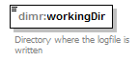
namespace | http://schemas.deltares.nl/dimr
type | restriction of xs:string
properties
  content | simple
facets
  Kind | Value | Annotation
  minLength | 1
annotation
  documentation
  Directory where the logfile is written
source | <xs:element name="workingDir" minOccurs="1" maxOccurs="1">  <xs:annotation>  <xs:documentation>Directory where the logfile is written</xs:documentation>  </xs:annotation>  <xs:simpleType>  <xs:restriction base="xs:string">  <xs:minLength value="1"/>  </xs:restriction>  </xs:simpleType>  </xs:element>

element DimrLoggerXML/outputFile
diagram | 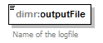
namespace | http://schemas.deltares.nl/dimr
type | xs:string
properties
  content | simple
annotation
  documentation
  Name of the logfile
source | <xs:element name="outputFile" type="xs:string" minOccurs="1" maxOccurs="1">  <xs:annotation>  <xs:documentation>Name of the logfile</xs:documentation>  </xs:annotation>  </xs:element>

complexType dimrParallelXML
diagram | 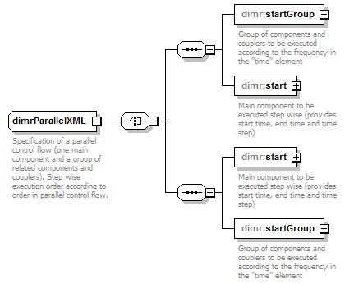
namespace | http://schemas.deltares.nl/dimr
children | dimr:startGroup dimr:start dimr:start dimr:startGroup
used by
  element | dimrControlXML/parallel
annotation
  documentation
  Specification of a parallel control flow (one main component and a group of related components and couplers). Step wise execution order according to order in parallel control flow.
source | <xs:complexType name="dimrParallelXML">  <xs:annotation>  <xs:documentation>Specification of a parallel control flow (one main component and a group of related components and couplers). Step wise execution order according to order in parallel control flow.</xs:documentation>  </xs:annotation>  <xs:choice>  <xs:sequence>  <xs:element name="startGroup" type="dimr:dimrStartGroupXML">  <xs:annotation>  <xs:documentation>Group of components and couplers to be executed according to the frequency in the "time" element</xs:documentation>  </xs:annotation>  </xs:element>  <xs:element name="start" type="dimr:dimrComponentOrCouplerRefXML">  <xs:annotation>  <xs:documentation>Main component to be executed step wise (provides start time, end time and time step)</xs:documentation>  </xs:annotation>  </xs:element>  </xs:sequence>  <xs:sequence>  <xs:element name="start" type="dimr:dimrComponentOrCouplerRefXML">  <xs:annotation>  <xs:documentation>Main component to be executed step wise (provides start time, end time and time step)</xs:documentation>  </xs:annotation>  </xs:element>  <xs:element name="startGroup" type="dimr:dimrStartGroupXML">  <xs:annotation>  <xs:documentation>Group of components and couplers to be executed according to the frequency in the "time" element</xs:documentation>  </xs:annotation>  </xs:element>  </xs:sequence>  </xs:choice>  </xs:complexType>

element dimrParallelXML/startGroup
diagram | 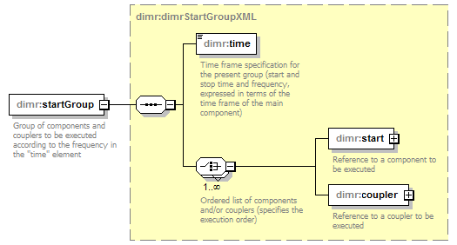
namespace | http://schemas.deltares.nl/dimr
type | dimr:dimrStartGroupXML
properties
  content | complex
children | dimr:time dimr:start dimr:coupler
annotation
  documentation
  Group of components and couplers to be executed according to the frequency in the "time" element
source | <xs:element name="startGroup" type="dimr:dimrStartGroupXML">  <xs:annotation>  <xs:documentation>Group of components and couplers to be executed according to the frequency in the "time" element</xs:documentation>  </xs:annotation>  </xs:element>

element dimrParallelXML/start
diagram | 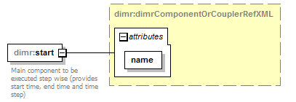
namespace | http://schemas.deltares.nl/dimr
type | dimr:dimrComponentOrCouplerRefXML
properties
  content | complex
attributes
  Name | Type | Use | Default | Fixed | Annotation
  name | xs:string | required
annotation
  documentation
  Main component to be executed step wise (provides start time, end time and time step)
source | <xs:element name="start" type="dimr:dimrComponentOrCouplerRefXML">  <xs:annotation>  <xs:documentation>Main component to be executed step wise (provides start time, end time and time step)</xs:documentation>  </xs:annotation>  </xs:element>

element dimrParallelXML/start
diagram
namespace | http://schemas.deltares.nl/dimr
type | dimr:dimrComponentOrCouplerRefXML
properties
  content | complex
attributes
  Name | Type | Use | Default | Fixed | Annotation
  name | xs:string | required
annotation
  documentation
  Main component to be executed step wise (provides start time, end time and time step)
source | <xs:element name="start" type="dimr:dimrComponentOrCouplerRefXML">  <xs:annotation>  <xs:documentation>Main component to be executed step wise (provides start time, end time and time step)</xs:documentation>  </xs:annotation>  </xs:element>

element dimrParallelXML/startGroup
diagram
namespace | http://schemas.deltares.nl/dimr
type | dimr:dimrStartGroupXML
properties
  content | complex
children | dimr:time dimr:start dimr:coupler
annotation
  documentation
  Group of components and couplers to be executed according to the frequency in the "time" element
source | <xs:element name="startGroup" type="dimr:dimrStartGroupXML">  <xs:annotation>  <xs:documentation>Group of components and couplers to be executed according to the frequency in the "time" element</xs:documentation>  </xs:annotation>  </xs:element>

complexType dimrSequentialXML
diagram | 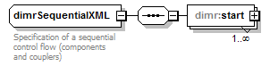
namespace | http://schemas.deltares.nl/dimr
children | dimr:start
annotation
  documentation
  Specification of a sequential control flow (components and couplers)
source | <xs:complexType name="dimrSequentialXML">  <xs:annotation>  <xs:documentation>Specification of a sequential control flow (components and couplers)</xs:documentation>  </xs:annotation>  <xs:sequence>  <xs:element name="start" type="dimr:dimrComponentOrCouplerRefXML" maxOccurs="unbounded"/>  </xs:sequence>  </xs:complexType>

element dimrSequentialXML/start
diagram | 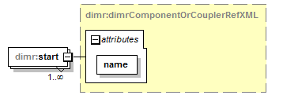
namespace | http://schemas.deltares.nl/dimr
type | dimr:dimrComponentOrCouplerRefXML
properties
  minOcc | 1
  maxOcc | unbounded
  content | complex
attributes
  Name | Type | Use | Default | Fixed | Annotation
  name | xs:string | required
source | <xs:element name="start" type="dimr:dimrComponentOrCouplerRefXML" maxOccurs="unbounded"/>

complexType dimrStartGroupXML
diagram | 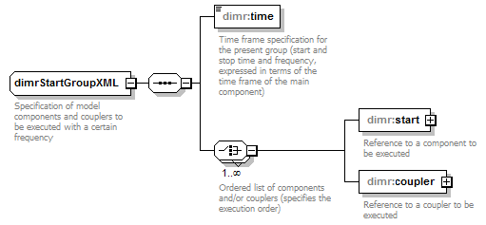
namespace | http://schemas.deltares.nl/dimr
children | dimr:time dimr:start dimr:coupler
used by
  elements | dimrParallelXML/startGroup dimrParallelXML/startGroup
annotation
  documentation
  Specification of model components and couplers to be executed with a certain frequency
source | <xs:complexType name="dimrStartGroupXML">  <xs:annotation>  <xs:documentation>Specification of model components and couplers to be executed with a certain frequency</xs:documentation>  </xs:annotation>  <xs:sequence>  <xs:element name="time" type="xs:string">  <xs:annotation>  <xs:documentation>Time frame specification for the present group (start and stop time and frequency, expressed in terms of the time frame of the main component)</xs:documentation>  </xs:annotation>  </xs:element>  <xs:choice maxOccurs="unbounded">  <xs:annotation>  <xs:documentation>Ordered list of components and/or couplers (specifies the execution order) </xs:documentation>  </xs:annotation>  <xs:element name="start" type="dimr:dimrComponentOrCouplerRefXML">  <xs:annotation>  <xs:documentation>Reference to a component to be executed</xs:documentation>  </xs:annotation>  </xs:element>  <xs:element name="coupler" type="dimr:dimrComponentOrCouplerRefXML">  <xs:annotation>  <xs:documentation>Reference to a coupler to be executed</xs:documentation>  </xs:annotation>  </xs:element>  </xs:choice>  </xs:sequence>  </xs:complexType>

element dimrStartGroupXML/time
diagram | 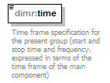
namespace | http://schemas.deltares.nl/dimr
type | xs:string
properties
  content | simple
annotation
  documentation
  Time frame specification for the present group (start and stop time and frequency, expressed in terms of the time frame of the main component)
source | <xs:element name="time" type="xs:string">  <xs:annotation>  <xs:documentation>Time frame specification for the present group (start and stop time and frequency, expressed in terms of the time frame of the main component)</xs:documentation>  </xs:annotation>  </xs:element>

element dimrStartGroupXML/start
diagram | 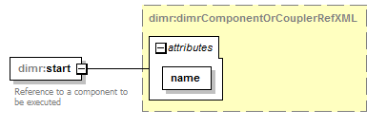
namespace | http://schemas.deltares.nl/dimr
type | dimr:dimrComponentOrCouplerRefXML
properties
  content | complex
attributes
  Name | Type | Use | Default | Fixed | Annotation
  name | xs:string | required
annotation
  documentation
  Reference to a component to be executed
source | <xs:element name="start" type="dimr:dimrComponentOrCouplerRefXML">  <xs:annotation>  <xs:documentation>Reference to a component to be executed</xs:documentation>  </xs:annotation>  </xs:element>

element dimrStartGroupXML/coupler
diagram | 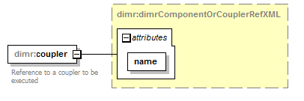
namespace | http://schemas.deltares.nl/dimr
type | dimr:dimrComponentOrCouplerRefXML
properties
  content | complex
attributes
  Name | Type | Use | Default | Fixed | Annotation
  name | xs:string | required
annotation
  documentation
  Reference to a coupler to be executed
source | <xs:element name="coupler" type="dimr:dimrComponentOrCouplerRefXML">  <xs:annotation>  <xs:documentation>Reference to a coupler to be executed</xs:documentation>  </xs:annotation>  </xs:element>

complexType dimrXML
diagram | 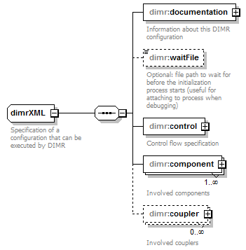
namespace | http://schemas.deltares.nl/dimr
children | dimr:documentation dimr:waitFile dimr:control dimr:component dimr:coupler
used by
  element | dimrConfig
annotation
  documentation
  Specification of a configuration that can be executed by DIMR
source | <xs:complexType name="dimrXML">  <xs:annotation>  <xs:documentation>Specification of a configuration that can be executed by DIMR</xs:documentation>  </xs:annotation>  <xs:sequence>  <xs:element name="documentation" type="dimr:dimrDocumentationXML">  <xs:annotation>  <xs:documentation>Information about this DIMR configuration</xs:documentation>  </xs:annotation>  </xs:element>  <xs:element name="waitFile" type="xs:string" minOccurs="0">  <xs:annotation>  <xs:documentation>Optional: file path to wait for before the initialization process starts (useful for attaching to process when debugging)</xs:documentation>  </xs:annotation>  </xs:element>  <xs:element name="control" type="dimr:dimrControlXML">  <xs:annotation>  <xs:documentation>Control flow specification</xs:documentation>  </xs:annotation>  </xs:element>  <xs:element name="component" type="dimr:dimrComponentXML" maxOccurs="unbounded">  <xs:annotation>  <xs:documentation>Involved components</xs:documentation>  </xs:annotation>  </xs:element>  <xs:element name="coupler" type="dimr:dimrCouplerXML" minOccurs="0" maxOccurs="unbounded">  <xs:annotation>  <xs:documentation>Involved couplers</xs:documentation>  </xs:annotation>  </xs:element>  </xs:sequence>  </xs:complexType>

element dimrXML/documentation
diagram | 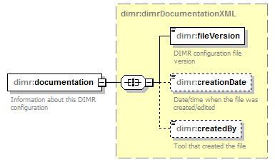
namespace | http://schemas.deltares.nl/dimr
type | dimr:dimrDocumentationXML
properties
  content | complex
children | dimr:fileVersion dimr:creationDate dimr:createdBy
annotation
  documentation
  Information about this DIMR configuration
source | <xs:element name="documentation" type="dimr:dimrDocumentationXML">  <xs:annotation>  <xs:documentation>Information about this DIMR configuration</xs:documentation>  </xs:annotation>  </xs:element>

element dimrXML/waitFile
diagram | 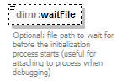
namespace | http://schemas.deltares.nl/dimr
type | xs:string
properties
  minOcc | 0
  maxOcc | 1
  content | simple
annotation
  documentation
  Optional: file path to wait for before the initialization process starts (useful for attaching to process when debugging)
source | <xs:element name="waitFile" type="xs:string" minOccurs="0">  <xs:annotation>  <xs:documentation>Optional: file path to wait for before the initialization process starts (useful for attaching to process when debugging)</xs:documentation>  </xs:annotation>  </xs:element>

element dimrXML/control
diagram | 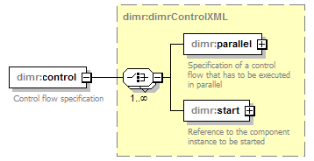
namespace | http://schemas.deltares.nl/dimr
type | dimr:dimrControlXML
properties
  content | complex
children | dimr:parallel dimr:start
annotation
  documentation
  Control flow specification
source | <xs:element name="control" type="dimr:dimrControlXML">  <xs:annotation>  <xs:documentation>Control flow specification</xs:documentation>  </xs:annotation>  </xs:element>

element dimrXML/component
diagram | 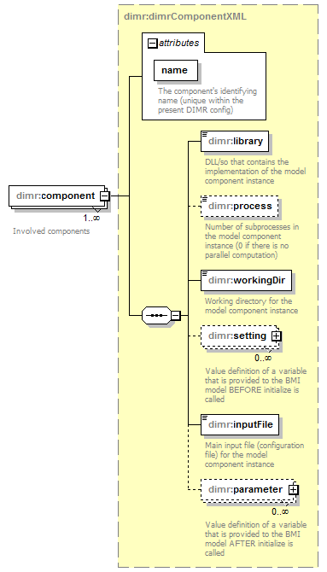
namespace | http://schemas.deltares.nl/dimr
type | dimr:dimrComponentXML
properties
  minOcc | 1
  maxOcc | unbounded
  content | complex
children | dimr:library dimr:process dimr:workingDir dimr:setting dimr:inputFile dimr:parameter
attributes
  Name | Type | Use | Default | Fixed | Annotation
  name | xs:string | required
    documentation
    The component's identifying name (unique within the present DIMR config)
annotation
  documentation
  Involved components
source | <xs:element name="component" type="dimr:dimrComponentXML" maxOccurs="unbounded">  <xs:annotation>  <xs:documentation>Involved components</xs:documentation>  </xs:annotation>  </xs:element>

element dimrXML/coupler
diagram | 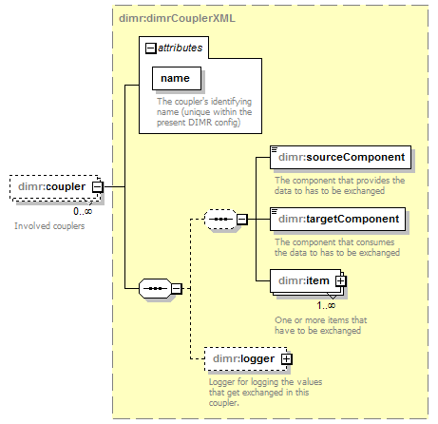
namespace | http://schemas.deltares.nl/dimr
type | dimr:dimrCouplerXML
properties
  minOcc | 0
  maxOcc | unbounded
  content | complex
children | dimr:sourceComponent dimr:targetComponent dimr:item dimr:logger
attributes
  Name | Type | Use | Default | Fixed | Annotation
  name | xs:string | required
    documentation
    The coupler's identifying name (unique within the present DIMR config)
annotation
  documentation
  Involved couplers
source | <xs:element name="coupler" type="dimr:dimrCouplerXML" minOccurs="0" maxOccurs="unbounded">  <xs:annotation>  <xs:documentation>Involved couplers</xs:documentation>  </xs:annotation>  </xs:element>

XML Schema documentation generated by XMLSpy Schema Editor http://www.altova.com/xmlspy

